WEEK 3(Aug. 12th to 16th):

An HTML form is used to collect user input. The user input is most often sent to a server for processing. The HTML <form> element is used to create an HTML form for user input:

<form>  
*form elements*  
</form>

What is CSS?

* CSS stands for Cascading Style Sheets
* CSS describes how HTML elements are to be displayed on screen, paper, or in other media

CSS Syntax

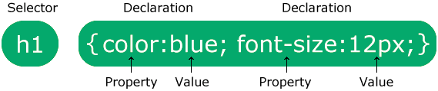

A CSS comment is placed inside the <style> element, and starts with /\* and ends with \*/

Colors are specified using predefined color names, or RGB, HEX, HSL, RGBA, HSLA values.

The border-style property specifies what kind of border to display.

The CSS margin properties are used to create space around elements, outside of any defined borders.

The CSS padding properties are used to generate space around an element's content, inside of any defined borders.

The simplest way to add an icon to your HTML page, is with an icon library, such as Font Awesome.

Links can be styled with any CSS property (e.g. color, font-family, background, etc.).